**Finance | Why oil price is spiking again**

**财经|为何石油价格再次飙升**

（英文部分选自经济学人20220604期财经版块）

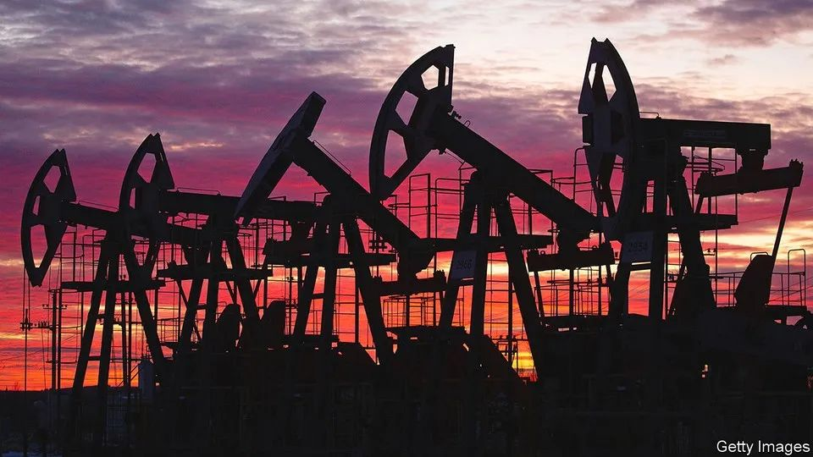

**Crude calculations**

**原油背后的算计**

Why oil price is spiking again

为何石油价格再次飙升

**Darker days for Russian oil**

**俄罗斯石油的至暗时刻**

In the 1970s Arab states used the “oil weapon” of embargoes to punish Western governments for supporting Israel. On May 30th the heads of the 27 eu member governments agreed to turn the weapon on themselves, as part of a fresh round of sanctions against Russia following its invasion of Ukraine. As well as cutting off Sberbank, Russia’s largest bank, from the swift cross-border payment system, the package will also ban purchases of Russian crude oil and refined products, such as diesel, **by the end of the year.** There would, the eu said, be a “temporary” exemption for oil delivered through pipelines. The price of a barrel of Brent crude leapt above $120 on the news, its highest level since March.

上世纪70年代，阿拉伯国家以石油为武器，通过禁运来惩罚支持以色列的西方政府。5月30日，27个欧盟成员国政府决定将这一武器为自己所用，作为俄乌冲突爆发以来新一轮对俄制裁的一部分。除了将俄罗斯最大银行联邦储蓄银行Sberbank移出SWIFT全球支付系统之外，此轮制裁还规定将在**年底前**禁止购买俄罗斯原油和精炼产品，如柴油。欧盟同时表示通过管道输送的石油将“暂时”豁免。消息一出，北海布伦特原油的价格登时飙升至每桶120美元以上，创下3月以来的新高。

**In principle**, the decision is highly significant. As well as demonstrating unity, and the bloc’s willingness to bear economic pain to punish Russia, it cuts one of the few remaining trade ties with the Kremlin. It also imperils one of Russia’s most lucrative sources of foreign-currency earnings. The eu is Russia’s biggest market for crude, buying about half the country’s oil exports.

**理论上，**这个决定意义重大：它展现了欧盟的团结，以及其宁愿承受经济损失也要惩罚俄罗斯的态度。本轮制裁切断了欧洲与克里姆林宫所剩不多的贸易联系之一，并危及俄罗斯最有利可图的外汇收入来源之一。欧盟是俄罗斯原油的最大买家：俄罗斯出口的黑金，有一半流入了欧盟。

There are reasons, however, to be sceptical that the move will deprive the Kremlin of much foreign currency. For a start, the ban applies only to seaborne oil, transported via tankers. That is the price of unity: excluding oil delivered by pipelines was necessary to find a compromise with Hungary, which is both more sympathetic to Russia than most eu countries and critically dependent on the Soviet-era Druzhba pipeline (a name meaning “friendship” in Russian). Hungary imports about 65% of its crude from Russia.

然而，禁运措施落地后，克林姆林宫是否会流失大量外汇？对此我们仍有理由质疑。首先，禁运仅针对由油轮经海路运输的石油。而这就是团结的代价：各国不得不将通过管道输送的石油排除在禁运名单之外，以其与匈牙利达成妥协。相较于大多数欧盟国家，匈牙利与俄罗斯更有“共同语言”，而且高度依赖苏联时期铺设的德鲁日巴管道（在俄语中，德鲁日巴“Druzhba”意为“友谊”）：俄罗斯进口原油占到了匈牙利石油总消费量的65%。

Seaborne oil makes up a similar share of Europe’s imports from Russia. But the ban is likely to have a limited impact on the oil market. Many tankers are already subject to “self-sanctioning” in parts of the West. Dockworkers have refused to unload ships carrying Russian cargoes and oil majors have been worried about the hit to their reputations from accepting shipments. Western financiers are stepping back from writing insurance contracts. Insurers based in Russia’s allies could partly replace them, **but have shallower pockets**.

欧洲进口的俄罗斯原油约有六成半通过海路运输。然而，该禁运令可能只会对石油市场造成有限影响。在西方部分地区，许多油轮现已饱尝“自我制裁”之苦：载有俄罗斯货物的船只靠港时，码头工人拒绝卸货；石油巨头担忧若买入俄罗斯石油，自身企业名誉会受损；西方金融界正暂缓与俄罗斯签订保险合同。尽管来自俄罗斯“友好国家”的保险机构可以某种程度上取而代之，**但其资金规模却相形见绌**。

A big question is whether Russian seaborne crude, once placed under sanctions, will **go unsold**. So far Russia’s oil exports have risen even as the country has come under sanctions. According to analysts at JPMorgan Chase, a bank, much of the increase has gone to India, which has not issued sanctions of its own.

一个关键的问题是，经由海路运输的俄罗斯原油在蒙受制裁后，会否**失去销路**？截至目前，尽管承受了诸多制裁，俄罗斯石油出口仍不断上升。美国银行摩根大通的分析师们表示，这在很大程度上要归功于印度：该国没有对俄罗斯实施制裁，反而还进口了大量俄罗斯石油。

Another question is whether Europe does eventually ban piped Russian oil, which is harder to redirect to other countries. Poland and Germany have said they will cease importing via the Druzhba pipeline. Yet it is hard to imagine Hungary’s dropping its opposition to a wider ban. Viktor Orban, the country’s populist prime minister, has demonstrated his willingness to block eu decisions before. Thanks to a hefty discount on Russian crude—the Urals benchmark is trading significantly below Brent— mol, a Hungarian oil group, reports “skyrocketing” margins.

另一个问题是，欧洲最终是否会禁运通过管道输送的俄罗斯石油（由于管道运输的特性，这部分石油更难转卖到其他国家）。波兰和德国已经表示，他们将停止通过德鲁日巴输油管道进口石油。然而，很难想象匈牙利会对打击面更广的石油禁运令开绿灯：该国的民粹主义总理维克托·欧尔班(Viktor Orban)此前就曾在欧盟重大决定中作梗。由于俄罗斯原油大幅度降价（乌拉尔原油的交易价格远低于北海布伦特原油），匈牙利石油公司MOL称其利润率“一飞冲天”。

Partial though the embargo may be, such is the tightness of the oil market that prices still surged. Demand for fuel is strong as the pandemic subsides and consumers start driving and flying again, and as governments try to shield voters from the impact of higher energy costs. China’s easing of **coronavirus restrictions** in recent days has also added to the thirst for oil. The prices of industrial metals, including iron ore and copper, have rallied, too.

尽管禁运只针对海路运输的原油，但石油市场供应十分紧张，以至于石油价格仍在飙升。随着疫情的消退，消费者们又开始驾车或乘坐飞机出行，同时政府也在试图保护选民免受能源成本上涨的影响，这些都导致对燃料的需求十分强劲。中国近日放松了部分**疫情管控**措施，这也导致了石油需求的上升。包括铁矿石和铜在内的工业金属价格也出现了上涨。

Meanwhile, the Organisation of the Petroleum Exporting Countries (opec) and its allies, which include Russia, **have shown little sign of increasing production just yet**. The group was due to meet on June 2nd, as we went to press, and was not expected to depart from its plan to gradually increase supply to levels seen before the pandemic (although prices dipped on reports that it was mulling a plan to exclude Russia from its production targets, allowing Saudi Arabia and others to pump more to make up for any lost output).

与此同时，欧佩克及其盟友（其中就有俄罗斯）**也没有表露出要增产的意思**。欧佩克原定于6月2日（本期杂志付印当天）召开会议，此次会议预计不会偏离其逐步将供应量增加到疫情爆发前水平的计划——尽管有报道称，欧佩克正在考虑一项计划，将俄罗斯排除在产量目标之外，并允许沙特阿拉伯和其它国家增加产量，以弥补由此带来的产量损失。

**Tight supply and robust demand together translate into higher prices for consumers at the pump. To make matters worse**, a shortage of refinery capacity in America has raised prices for petrol and diesel even further than the cost of crude. The surging dollar adds to costs for Europe and emerging markets, notes Francisco Blanch of Bank of America. None of this is welcome news in an already inflationary environment. According to figures published on May 31st inflation in the euro area rose to 8.1% in the year to May, higher than economists had expected.

**供应紧张和需求强劲造成加油站油价高企。雪上加霜的是**，美国炼油产能匮乏进一步抬高了汽油和柴油价格，使其价格涨幅远超原油价格涨幅。美国银行的弗朗西斯科·布兰奇（Francisco Blanch）指出，在欧洲和新兴市场，飙升的价格增加了成本。在当前的通胀环境下，这些消息无不令人感到沮丧。根据5月31日公布的数据，截止5月，欧元区的通胀率上升至8.1％，高于经济学家的预期。

**The Arab embargoes of the 1970s** caused short-term pain for the West, but also spurred a drive for fuel efficiency that ultimately reduced its reliance on oil. European governments today may find themselves hoping that the **short-term pain for consumers similarly gives way to the long-term gain of** energy security.

**上世纪70年代，阿拉伯国家**的石油禁运造成了西方世界的短期恐慌，但同时也推动了燃油效率的提高，最终减少了西方对石油的依赖。如今的欧洲政府可能正在祈望，**消费者的短期苦痛能带来能源安全的长期收益**。

